Plant Assessment

As per the Requirements, Planit Repository has been created which has basic Automation framework and all required automated tests.

Test Automation Framework:

As per requirements, this framework is not a BDD framework.

After Analysing the application and requirements and time constraints. i decided to go with Hybrid approach.

It is Hybrid Framework which consists of Modular, and data driven frameworks.

Page Object Modal has been used in this framework which gives more scalability and flexibility while automating the tests.

Modular framework makes more cleaner and independent modules which are easy to maintain and highly scalable.

Data driven framework makes execution more flexible, tests can be run against multiple data sets without any hassle.

TestNG is execution framework which helps to execute the tests more efficiently and support automation testing in many ways.

**Automation Framework Architecture:**

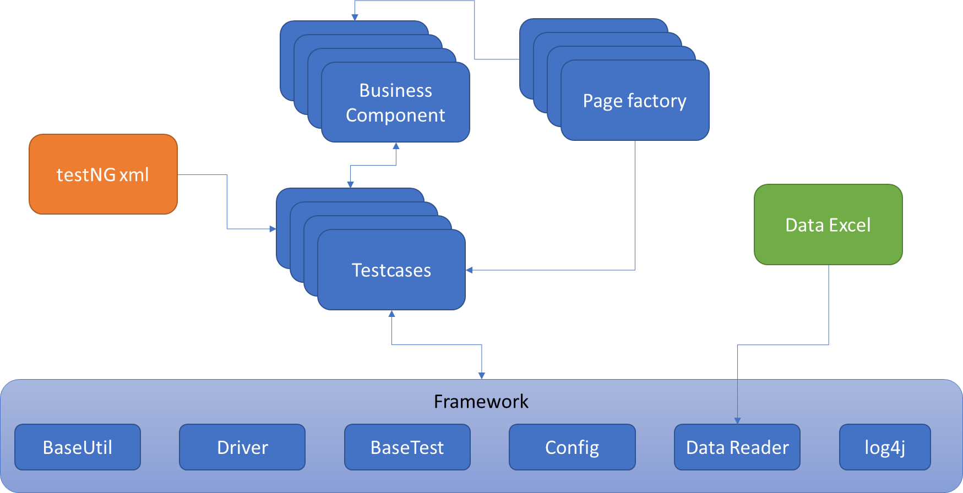

**File Structure:**

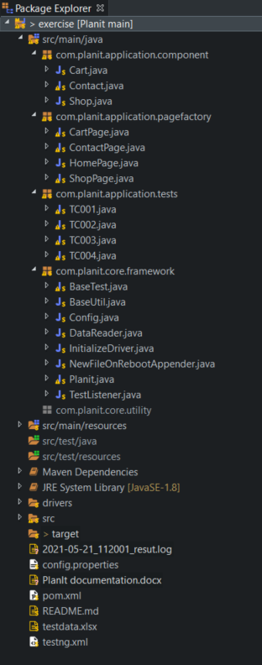

Automation Frameworks has different components below are the list of them with description.

1. TestNG xml: testing xml is the driver of the test cases, where we can configure the test cases which we want to execute.
2. Test Cases: test cases are placed in separate package where all dedicated test cases can be stored. We can also create multiple packages as per application needs to make the test cases more organized.
3. Page Factory: ideally number of application pages equals to number of page factory classes. In the page factory, we identify and list down all elements on that page. Along with that, we can also write basic method for that class, such as click on elements, enter data, form fill , etc. page factory is most important concept in POM structure.
4. Business Component: most of the applications has several features and several flows. While writing the test cases, most of the time we can use some portion of code from other. It is always advisable to use business component strategy which helps great scalability, modularity and easy to maintain solution. Business component usually has commonly used business logic for a particular feature.
5. Framework: Framework is brain of the automation framework. Framework components co-ordinates with other components and helps to automate the test with ease. Framework reads the data and provide to test cases, also it manages the webdriver. It also has helper classes such as BaseTest and BaseUtil to help testers with common functionality to avoid repetitive tasks. It also manages the configurations of the project for better management.
6. Data Excel: for this framework, I used Excel sheet as data source for the test case. Excel is one of most used tools and often used for storing test data or even test cases. Based on application-to-application strategy of data storage changes. I always prefer to keep data in database rather than excel as it is easy to maintain.